**Does Trump have a bunch of 'losers' to thank for a growing economy?**

By Charles Hall, Opinion Contributor — 11/16/19 05:00 PM EST [528](https://thehill.com/opinion/energy-environment/470782-does-trump-have-a-bunch-of-losers-to-thank-for-a-growing-economy#bottom-story-socials)

The views expressed by contributors are their own and not the view of The Hill

57

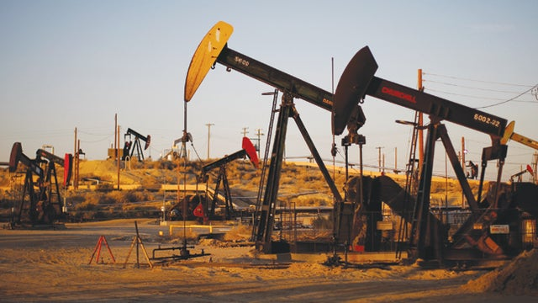

© Getty Images

The media and the general public tend to give political leaders the credit, or blame, for the state of the economy. This is clearly the case with President [Trump](https://thehill.com/person/trump), much of whose popularity, such as it is, is based on the good health of the U.S. economy. But is the economy doing well because of Trump’s economic policies, such as the reduction of tax rates, or something else entirely that economists have missed?

There are many complex factors that determine the state of the economy, but only one absolute prerequisite — available and affordable energy to manufacture and move things to market, and to transport, feed, comfort and amuse people.

In the U.S. and the rest of the industrialized world this means principally liquid and gaseous petroleum. For many natural scientists, this is clearly [extremely important,](http://reports.weforum.org/energy-for-economic-growth-energy-vision-update-2012/) perhaps even dominant, in the success or failure of economies.

ADVERTISEMENT

Today in the U.S. oil is [less than $55 a barrel,](https://oilprice.com/) and gas is about [as cheap as it has ever been](https://www.forbes.com/sites/judeclemente/2019/06/23/u-s-natural-gas-prices-have-collapsed/#78eefad7286e). We have decreased our oil imports to about 15 percent of use and become a [minor net exporter of gas](https://www.eia.gov/todayinenergy/detail.php?id=39312).

Despite improvements in wind and photovoltaic devices, and a decline in their manufacturing costs, our use of oil and gas [continues to increase](https://www.wsj.com/articles/u-s-oil-gas-hit-record-production-levels-in-2018-11560264922), although at a slower rate. Oil and natural gas in the U.S. are roughly [half as expensive](https://www.ibtimes.com/gas-prices-pump-europeans-pay-almost-twice-much-us-residents-1322727) today as in Europe or Asia, or in the U.S. during the Obama years. Today, as in 1972, it is often [as cheap](https://www.statista.com/statistics/252791/natural-gas-prices) to make things in America as elsewhere, even though our labor is more expensive. Trump’s timing from this perspective was excellent.

U.S. oil production originally [peaked in 1970,](https://en.wikipedia.org/wiki/Peak_oil) and [gas in 1973](https://en.wikipedia.org/wiki/Natural_gas_in_the_United_States), but declined through 2007, when production was revitalized by the process of lateral drilling and “fracking.” This technological miracle allowed us to exploit deposits formerly considered low-grade.

Now the United States produces more oil than it ever has, and is, with Saudi Arabia and Russia, one of [the top three oil producers](https://www.eia.gov/tools/faqs/faq.php?id=709&t=6) in the world. Fracking has also reversed the long decline of U.S. natural gas production, allowing the substitution of gas for coal and a proliferation of cheap plastics.

But, curiously, this renaissance of petroleum in the United States has [not led](https://www.nytimes.com/2019/06/30/business/energy-environment/oil-companies-profit.html) to a resurgence of profits in the oil and gas industry. Quite the opposite, because almost [none](https://www.desmogblog.com/2018/12/18/fracking-finances-record-oil-production-fuzzy-math) of the companies that have invested in fracking are turning a profit. Investors in this industry are losing a lot of money, some $83 billion since 2008, according to oil analyst Arthur Berman.

ADVERTISEMENT

This situation means that relatively cheap oil and gas are keeping the U.S. economy strong. But this cheap oil and gas is being partially subsidized by investors who are either losing money or receiving a poor return on investment. In this respect, President Trump has these financial “losers” to thank for a large part of the current health of the U.S. economy.

This relation among oil supplies, prices and the political winds is not new and works both ways. Presidents Gerald Ford and [Jimmy Carter](https://thehill.com/people/jimmy-carter) were in office during the economically disastrous increase in the [price of oil](https://www.eia.gov/dnav/pet/hist/LeafHandler.ashx?n=PET&s=F000000__3&f=A) from less than $4 a barrel in 1972 to more than $35 in 1979. Both lost in their reelection bids.

In 1980 and 1984, [Ronald Reagan](https://thehill.com/person/ronald-reagan) ran on a platform of “Let’s make America Great again” and “It’s morning again in America,” which coincided with the decline in oil prices during the 1980s. In the U.K., [Margaret Thatcher](https://thehill.com/person/margaret-thatcher) was floundering in popularity in 1980, but then received most of the credit for the [remarkable recovery](https://www.economicshelp.org/blog/630/economics/economy-in-1980s/) of the U.K. economy. Was it her conservative management style, or the development of the North Sea oil, which occurred on her watch? Now that the [North Sea oil boom is over](https://www.theguardian.com/commentisfree/2013/apr/19/north-sea-oil-80s-boom), the U.K. economy is [struggling again](https://www.theguardian.com/business/2019/aug/09/uk-economy-contracts-on-back-of-brexit-uncertainty).

So again the U.S. [economy is booming,](https://www.cnbc.com/2019/11/15/dow-futures-fed-reserve-financial-stability-report.html) continuing to grow since the large economic contraction of 2008, which in turn followed the brief but dramatic [oil price spike to $140 a barrel](https://marginalrevolution.com/marginalrevolution/2008/06/with-oil-at-140.html) that had occurred earlier in that year. There is a [significant correlation](https://www.pewresearch.org/fact-tank/2013/07/25/can-a-president-control-gas-prices-depends-on-when-you-ask/) between energy prices and presidential popularity. While oil price is not the only predictor, it is too often ignored in our personality- and social media-driven world (which, of course, is underwritten by fossil fuels).

Ironically, President Trump’s prospects there are tied in part to American investors being willing to continue to lose money seeking shale oil.

*Charles Hall is professor emeritus at SUNY College of Environmental Sciences and Forestry in Syracuse, N.Y., and author of 14 books and 300 scientific articles related to energy, environment and economics.*